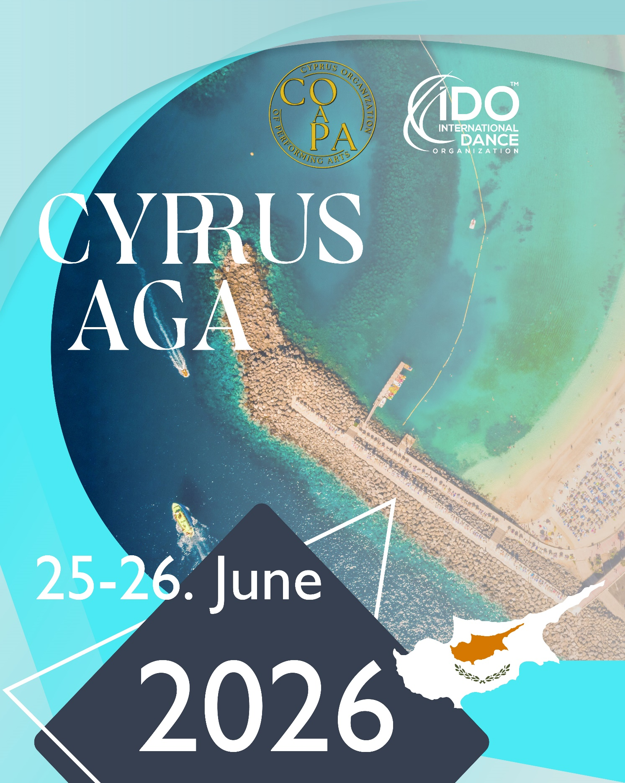

ANNUAL GENERAL ASSEMBLY MEETING 2026

FINAL AGENDA

PAPHOS, CYPRUS

Venue:
King Evelthon Beach Hotel & Resort
Address: Q9QX+VQQ, Chlorakas 8220, Cyprus

Time zone (GMT+3)
TIME SCHEDULE:
June 24, 2026 (Wednesday)
12:00-15:00 Executive Presidium Meeting (EPM)
14:00- arrivals of Presidium members and delegates

June 25, 2026 (Thursday)
09:30-10:00 registration of the Forum attendees
10:00-12:30 IDO Members’ Forum (I)
12:30-13:30 lunch break
13:30-14:00 registration of the AGA delegates
14:00-15:45 Annual General Assembly Meeting (I)
15:45-16:00 coffee break
16:00-18:00 Annual General Assembly Meeting (II)
19:00- Cocktail Party hosted by the IDO - with finger foods and sweets

June 26, 2026 (Friday)
09:00-10:45 Annual General Assembly Meeting (III)
10:45-11:00 coffee break
11:00-12:30 Annual General Assembly Meeting (IV)
12:30-13:30 lunch break
13:45-15:15 Annual Continental Conference Meetings (Europe, Asia & Asia Pacific, Americas)
15:15-15:30 coffee break
15:30-17:00 IDO Members’ Forum (II)
17:00- departures

June 27, 2026 (Saturday)
departures
09:00-13:00 Presidium meeting
15:00-18:00 Supervisor Exam

June 28, 2026 (Sunday)
09:00-12:00 Chairperson Exam
Invited:

- Presidium members:

- Prof.dr.sc. Velibor Srdic, President (VS)
- Fiona Johnson, Senior Vice President for Sport and Sport for All, Chairperson of the Competition Managing Committee (FJ)
- Kirsten Dan Jensen, Executive Secretary and Treasurer, Chairperson of Street Dance Departmen, Ambassador for Africa (KDJ)
- Hana Svehlova, Vice President for Dance Sport Rules, Chairperson of Technical Committee, Chairperson of Performing Arts Department (HS)
- Trajche Petkovski, Vice President for Marketing and Communication (TP)
- Bonnie Dyer, Vice President for New Ventures, Ambassador for the Americas (BD)
- dr. Klaus Hoellbacher, Vice President for Archives, Statistics and Data Protection Manager, Chairperson of Membership Committee, Chairperson of Couple Dance Department (KH)
- Edilio Pagano, Vice President for Protocol and Festival, Chairperson of Education Committee (EP)
- Aleena Tan, Vice President at Large, Chairperson Continental Conference Asia (AT)

- Ex-officio Members of the Presidium
- Robert Planutis, Continental Chairperson for the Americas, Chairperson of Disciplinary and Ethic Committee, recording secretary (RP)
- Sylwana Patlaszynska, Chairperson of the Continental Conference Europe
- Michael Wendt, IDO Honorary Lifetime President, Ambassador for Asia & Asia Pacific (MW)
- Cory Lunny, Dancer’s Commission (CL)

- Elected and appointed IDO officials:
- Patrik Perosa, Advisor to the President (PP)

- Enrolled delegates by the IDO NMOs

Final list of the enrolled delegates will be published prior to the meeting depending on paid and non paid dues.

Dress Code:

Recommended dress code for the meetings is business casual.

Right to vote and speak:

- IDO members have right to vote and speak, if they have paid their dues.
- IDO contact persons and invited guests may also speak and discuss the items on the agenda without right to vote.
- We advise all IDO members to send the written questions about different reports and proposals to the Presidium, in advance, till June 10, 2026.
- Each IDO member has the right to speak for 3 (three) minutes on each subject and then an additional 1 (one) minute to reply.

Explanation of the voting rights for the:
Member type | Speak | Vote | Nominate | be nominated / elected
Members | yes | yes | yes | yes
Probationary Members | yes | yes | no | no
Contacts | yes | no | no | no

AGENDA

- Welcoming remarks of the President and introduction of delegates, invited guests and technical staff

- Minute of silence

- Determination of quorum
Quorum: At least 15 members present or represented by proxy.

Checking
  - voting delegates _____
  - non-voting delegates _____
  - translators _____
  - guests _____
  - quorum _____
  - majority of votes _____
  - 2/3 majority of votes _____

- Keeper of the Minutes
    - Mr. Robert Planutis
seconder
comment
votes for | votes against | abstained
RESULT
passed | failed | withdrawn

- Verification Committee- approval (2 delegates)
    - 2 persons (delegates) responsible for counting the votes and confirming the Minutes, from the floor
seconder
comment
votes for | votes against | abstained
RESULT
passed | failed | withdrawn

- Acceptance of the AGA Minutes (2025)- document available in DIES
seconder
comment
votes for | votes against | abstained
RESULT
passed | failed | withdrawn

- Membership Issues
  - Termination of membership
    - Membership cancellation at the request of the IDO national member (Plesni savez Crne Gore) from Montenegro. (ordinary member in 3 departments).
seconder
comment
votes for | votes against | abstained
RESULT
passed | failed | withdrawn

  - Acceptance of new members (Proposal 25 pp.98)
    - To accept Dance Sports Council of India, India as an ordinary member with probationary status in all three dance departments.
seconder
comment
votes for | votes against | abstained
RESULT
passed | failed | withdrawn

    - To accept Plesni savez Crne Gore from Montenegro as ordinary member with probationary status in all three dance departments.
seconder
comment
votes for | votes against | abstained
RESULT
passed | failed | withdrawn

  - Change of membership status
N/A

- Reports (please find the reports in the separate document Reports)

Report on activities of Continental Conferences in 2025

  - Europe (Reports pp.45)
seconder
comment
votes for | votes against | abstained
RESULT
passed | failed | withdrawn

  - The Americas (Reports pp.39)
seconder
comment
votes for | votes against | abstained
RESULT
passed | failed | withdrawn

  - Asia and Asia Pacific (Reports pp.43)
seconder
comment
votes for | votes against | abstained
RESULT
passed | failed | withdrawn

  - Africa (Reports pp.37)
seconder
comment
votes for | votes against | abstained
RESULT
passed | failed | withdrawn

Report on activities of Presidium members in 2025
  - President and Chairperson of the Adjudication Committee (Reports pp.1)
seconder
comment
votes for | votes against | abstained
RESULT
passed | failed | withdrawn

  - Patrik Perosa, MSc, Advisor to the President (Reports pp.7)
seconder
comment
votes for | votes against | abstained
RESULT
passed | failed | withdrawn

  - Senior Vice President for Sport and Sport for All (Reports pp.12)
seconder
comment
votes for | votes against | abstained
RESULT
passed | failed | withdrawn

  - Executive Secretary and Treasurer (Reports pp.18)
seconder
comment
votes for | votes against | abstained
RESULT
passed | failed | withdrawn

  - Financial Report 2025 (will be available on the IDO website - member area)
seconder
comment
votes for | votes against | abstained
RESULT
passed | failed | withdrawn

  - External Auditor’s Report 2025 (will be available on the IDO website - member area)
seconder
comment
votes for | votes against | abstained
RESULT
passed | failed | withdrawn

  - Internal Revisors Report 2025 (will be available on the IDO website – member area)
seconder
comment
votes for | votes against | abstained
RESULT
passed | failed | withdrawn

  - VP for Dance Sport Rules, Chairperson of Technical Committee (Reports pp.21)
seconder
comment
votes for | votes against | abstained
RESULT
passed | failed | withdrawn

  - Dancer’s Commission Chairperson (Reports pp.36)
seconder
comment
votes for | votes against | abstained
RESULT
passed | failed | withdrawn

  - VP for Archive, Statistical Department and Data Protection Manager (Reports pp.33)
seconder
comment
votes for | votes against | abstained
RESULT
passed | failed | withdrawn

  - VP for Protocol, and Festival, Education (Reports pp.34)
seconder
comment
votes for | votes against | abstained
RESULT
passed | failed | withdrawn

  - VP at Large (Reports pp.43)
seconder
comment
votes for | votes against | abstained
RESULT
passed | failed | withdrawn

  - VP for Marketing and Communication (Reports pp.24)
seconder
comment
votes for | votes against | abstained
RESULT
passed | failed | withdrawn

  - VP for New Ventures (Reports pp.32)
seconder
comment
votes for | votes against | abstained
RESULT
passed | failed | withdrawn

Report on activities of Dance Departments 2025
  - Street Dance (Reports pp.48)
seconder
comment
votes for | votes against | abstained
RESULT
passed | failed | withdrawn

  - Couple Dance (Reports pp.50)
seconder
comment
votes for | votes against | abstained
RESULT
passed | failed | withdrawn

  - Performing Arts (Reports pp.51)
seconder
comment
votes for | votes against | abstained
RESULT
passed | failed | withdrawn

  - Report Disciplinary and Ethic Committee (Reports pp.47)
seconder
comment
votes for | votes against | abstained
RESULT
passed | failed | withdrawn

  - Chairman of Appeal Committee (no cases till now)
seconder
comment
votes for | votes against | abstained
RESULT
passed | failed | withdrawn

  - Ambassador for WDC (Reports pp.54)
seconder
comment
votes for | votes against | abstained
RESULT
passed | failed | withdrawn

- Proposals to AGA (please find the proposals in the separate document Proposals)

PROPOSAL 1 (Proposals pp.1)
Regulation on the bidding procedure for hosting the Annual General Assembly (AGA) Meeting
seconder
comment
votes for | votes against | abstained
RESULT
passed | failed | withdrawn

PROPOSAL 2 (Proposals pp.6)
Submission deadlines and disciplinary procedures for the registration of the dancers
seconder
comment
votes for | votes against | abstained
RESULT
passed | failed | withdrawn

PROPOSAL 3 (Proposals pp.7)
Starting fee for combined events
seconder
comment
votes for | votes against | abstained
RESULT
passed | failed | withdrawn

PROPOSAL 4 (Proposals pp.8)
Starting fee structure
seconder
comment
votes for | votes against | abstained
RESULT
passed | failed | withdrawn

PROPOSAL 5 (Proposals pp.9)
Flat travel reimbursement policy
seconder
comment
votes for | votes against | abstained
RESULT
passed | failed | withdrawn

PROPOSAL 6 (Proposals pp.10)
Recognition of the official's past service
seconder
comment
votes for | votes against | abstained
RESULT
passed | failed | withdrawn

PROPOSAL 7 (Proposals pp.10)
Postponement of the IDO Gala 2026 to 2027
seconder
comment
votes for | votes against | abstained
RESULT
passed | failed | withdrawn

PROPOSAL 8 (Proposals pp.11)
Criteria and conditions for scrutineering exam
seconder
comment
votes for | votes against | abstained
RESULT
passed | failed | withdrawn

PROPOSAL 9 (Proposals pp.12)
IDO Scrutineering System – Requirements Document
seconder
comment
votes for | votes against | abstained
RESULT
passed | failed | withdrawn

PROPOSAL 10 (Proposals pp.16)
Chairperson and country name
seconder
comment
votes for | votes against | abstained
RESULT
passed | failed | withdrawn
PROPOSAL 11 (Proposals pp.17)
Supporting online system at IDO events
seconder
comment
votes for | votes against | abstained
RESULT
passed | failed | withdrawn

PROPOSAL 12 (Proposals pp.17)
Level-Based Classification Policy for IDO Chairpersons and Supervisors
seconder
comment
votes for | votes against | abstained
RESULT
passed | failed | withdrawn

PROPOSAL 13 (Proposals pp.20)
Procedure for the rehearsals
seconder
comment
votes for | votes against | abstained
RESULT
passed | failed | withdrawn

PROPOSAL 14 (Proposals pp.20)
Procedure and time limits for the rehearsals
seconder
comment
votes for | votes against | abstained
RESULT
passed | failed | withdrawn

PROPOSAL 15 (Proposals pp.20)
Majority rule in breaking battles rounds
seconder
comment
votes for | votes against | abstained
RESULT
passed | failed | withdrawn

PROPOSAL 16 (Proposals pp.20)
Judging of Groups and Formations
seconder
comment
votes for | votes against | abstained
RESULT
passed | failed | withdrawn

PROPOSAL 17 (Proposals pp.21)
Number of Adjudicators and Additional Official Adjudicators
seconder
comment
votes for | votes against | abstained
RESULT
passed | failed | withdrawn

PROPOSAL 18 (Proposals pp.21)
Medical decision and continuation of participation
seconder
comment
votes for | votes against | abstained
RESULT
passed | failed | withdrawn

PROPOSAL 19 (Proposals pp.22)
Time limits for setting props on and off the stage including the entering and leaving the stage
seconder
comment
votes for | votes against | abstained
RESULT
passed | failed | withdrawn

PROPOSAL 20 (Proposals pp.22)
Awards ceremony requirements
seconder
comment
votes for | votes against | abstained
RESULT
passed | failed | withdrawn

PROPOSAL 21 (Proposals pp.24)
Job descriptions of the IDO officials
seconder
comment
votes for | votes against | abstained
RESULT
passed | failed | withdrawn

PROPOSAL 22 (Proposals pp.87)
Decision about proposal for the participation of the Russian and Belarus dancers
seconder
comment
votes for | votes against | abstained
RESULT
passed | failed | withdrawn

PROPOSAL 23 (Proposals pp.94)
Establishment of the IDO company
seconder
comment
votes for | votes against | abstained
RESULT
passed | failed | withdrawn

PROPOSAL 24 (Proposals pp.98)
Changes of the IDO Statutes and By Laws
seconder
comment
votes for | votes against | abstained
RESULT
passed | failed | withdrawn

PROPOSAL 27 (Proposals pp.99)
Change of per diem for the IDO meetings
seconder
comment
votes for | votes against | abstained
RESULT
passed | failed | withdrawn

PROPOSAL 28 (Proposals pp.99)
Change of honorarium for the elected IDO Officials
seconder
comment
votes for | votes against | abstained
RESULT
passed | failed | withdrawn

PROPOSAL 29 (Proposals pp.99)
Election of the IDO internal revisors
seconder
comment
votes for | votes against | abstained
RESULT
passed | failed | withdrawn

PROPOSAL 30 (Proposals pp.100)
Job description of the IDO officials
seconder
comment
votes for | votes against | abstained
RESULT
passed | failed | withdrawn

PROPOSAL 31 (Proposals pp.101)
Template- Job description of the IDO officials
seconder
comment
votes for | votes against | abstained
RESULT
passed | failed | withdrawn

PROPOSAL 32 (Proposals pp.101)
Organizational structure of the IDO
seconder
comment
votes for | votes against | abstained
RESULT
passed | failed | withdrawn

PROPOSAL 33 (Proposals pp.102)
Account number and required information for the money transfer
seconder
comment
votes for | votes against | abstained
RESULT
passed | failed | withdrawn

PROPOSAL 34 (Proposals pp.102)
Definition of the elected official's goals
seconder
comment
votes for | votes against | abstained
RESULT
passed | failed | withdrawn

PROPOSAL 35 (Proposals pp.103)
Flyer for the IDO competition
seconder
comment
votes for | votes against | abstained
RESULT
passed | failed | withdrawn

PROPOSAL 36 (Proposals pp.104)
Starting fees at IDO events
seconder
comment
votes for | votes against | abstained
RESULT
passed | failed | withdrawn

PROPOSAL 37 (Proposals pp.105)
Interface for importing and registering dancers for dance competitions
seconder
comment
votes for | votes against | abstained
RESULT
passed | failed | withdrawn

PROPOSAL 38 (Proposals pp.105)
Analysis of the models and structure of the IDO Championships
seconder
comment
votes for | votes against | abstained
RESULT
passed | failed | withdrawn

PROPOSAL 39 (Proposals pp.107)
Judging systems in the IDO
seconder
comment
votes for | votes against | abstained
RESULT
passed | failed | withdrawn

PROPOSAL 40 (Proposals pp.110)
Waiving the dancer's fees in case of medical proof
seconder
comment
votes for | votes against | abstained
RESULT
passed | failed | withdrawn

PROPOSAL 41 – ELECTIONS of the 2 internal revisors for the 4 years term
Nominated are (by the date of nominations):
      - Sanja Adzic, Serbia (nominated by the NMO from Serbia)
      - Rugile Dailadaite, Lithuania (nominated by the NMO from Lithuania)
      - Kerstin Albrecht (nominated by the NMO from Germany)
      - Szymon Kowalewski (nominated by the NMO from Poland)

- Date and venue of the next AGA 2027
PROPOSAL 26 (Proposals pp.99)
Vienna, Austria
seconder
comment
votes for | votes against | abstained
RESULT
passed | failed | withdrawn

- Old business

- New business

NOTE 1:
- Closed (limited) Proxy to vote at General Assembly may be given to other members with the right to vote. The number of proxies held by any person is limited to one (1). Proxies cannot be used in the elections of members of the Presidium, Internal Revisor(s) and External Auditor, and in dissolution of the IDO.
- All members who are not able to come to AGA will be able to follow IDO AGA 2026 online. More information about it will be sent prior to the AGA.
- No member will have the right to vote if the IDO fees are not paid.

NOTE 2:
- Some countries will require Visas for Cyprus. Please check your national website for Visa requirements. Don't hesitate to get in touch with Mrs. Anastasia Kakogianni for a Visa Invitation Letter.

LOOKING FORWARD TO MEET YOU SOON!

Prof. dr. sc. Velibor Srdic
IDO President


